**NSW5110-18GP8GT-DT Managed Ethernet Switch**

## Overview

The Switch provides 16*1000Mbps SFP Slot, 2*1000Mbps SFP Slots and 8*10/100/1000Mbps RJ45 ports, powerful and flexible enough for users to deploy wireless access points or IP-based network surveillance cameras. The switch also comes equipped with 2G SFP slots, expanding your network flexibly. In addition, it provides high performance, enterprise-level QoS, advanced security strategies and rich layer 2 management features. With all these advanced features, the Switch is an ideal choice for WIFI coverage, Internet cafes, computer rooms, and so on.

* NSW5110-18GP8GT-DT

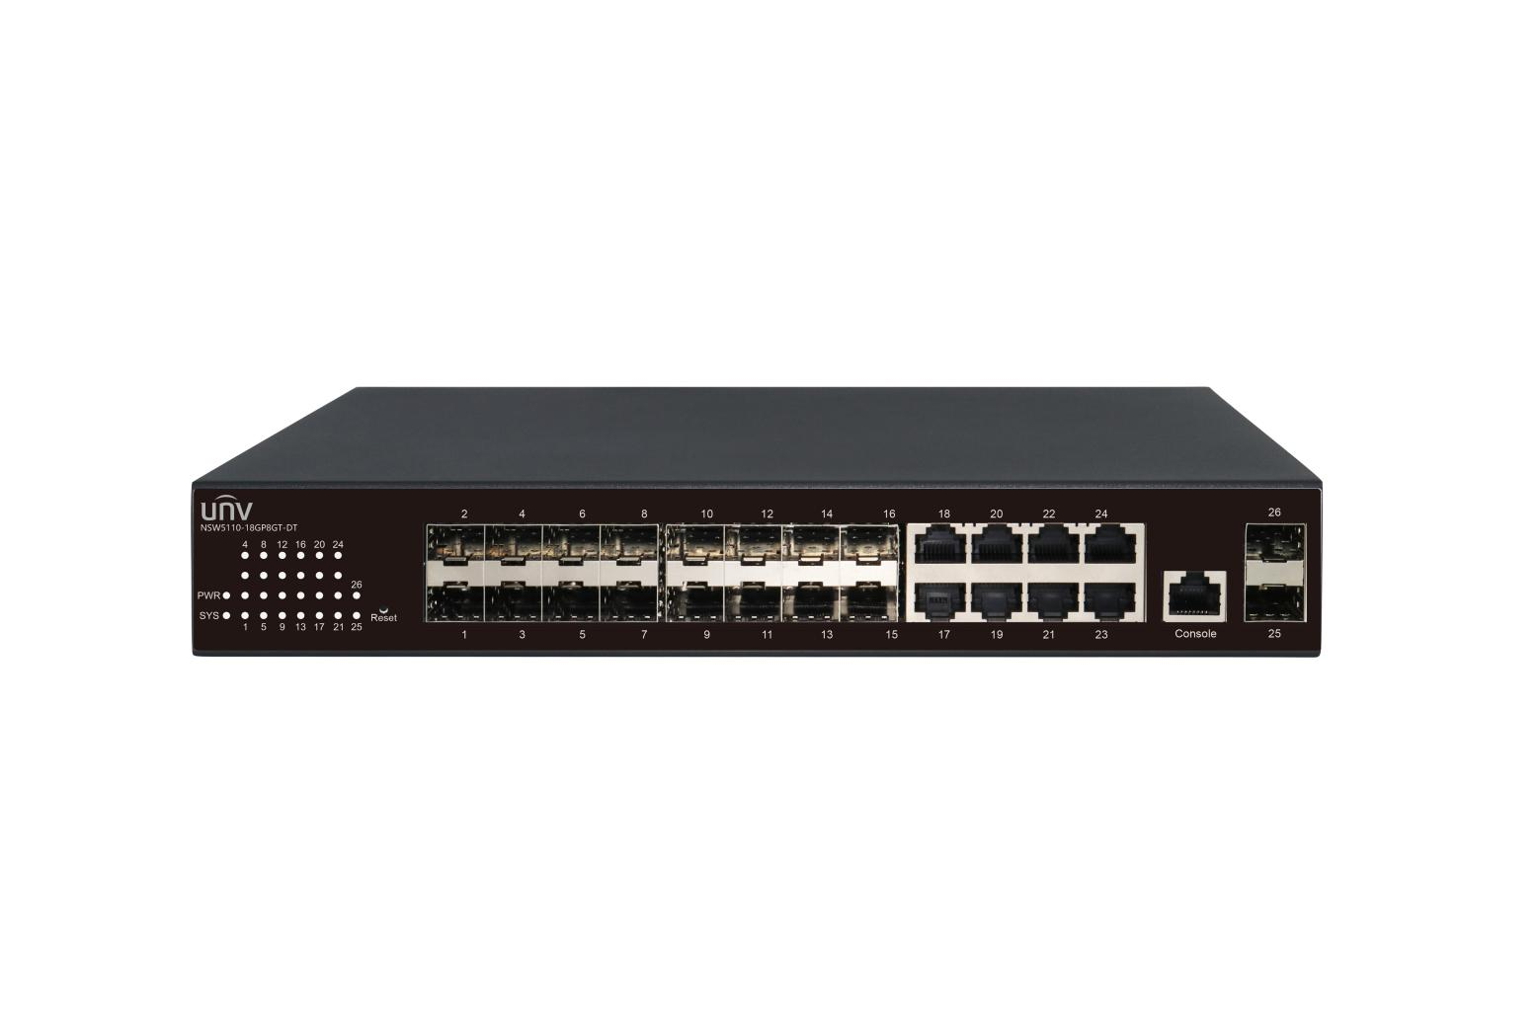

## Key Features

* Conform to the IEEE802.3, IEEE802.3u, IEEE802.3ab, IEEE802.3z, IEEE802.3x standard;
* RJ45 supports automatic port rollover (Auto MDI/MDIX) ;
* Panel lights to monitor working state and help fault analysis
* Supports IEEE802.3x full duplex flow control and Backpressure half duplex flow control
* Support Energy-Efficient Ethernet (EEE) function (IEEE802.3az)
* Supports a complete lineup of L2 features, including 802.1Q tag VLAN, Port Mirroring, STP/RSTP/MSTP, Link Aggregation Control Protocol and 802.3x Flow Control function
* Web, CLI (Console Port, Telnet, SSH), SNMP and RMON bring abundant management policies
* Data exchange adopts store-and-forward mode and line speed forwarding can be intelligently identified

## Specifications

|  |  |
| --- | --- |
| **Model** | 16G SFP+8GE+2G SFP |
| Ports | 16*1000Mbps SFP Slots  2*1000 SFP Slots  8*10/100/1000Mbps RJ45 ports  1*Console Port |
| Standards | IEEE802.3, IEEE802.3u, IEEE802.3ab, IEEE802.3z, IEEE802.3x, IEEE802.1X, IEEE802.1q, IEEE802.1p, IEEE802.1d, IEEE802.1w, IEEE802.3ad |
| Switching capacity | 52Gbps |
| Forwarding performance | 38.69Mpps |
| Packet Buffer | 4.1M bit |
| Jumbo frame | 10000Byte |
| MAC Address | 8K, Auto-learning, Auto-aging |
| Dimensions (L×W×H) | 280*180*44mm |
| Weight | <3.6kg |
| Power supply | AC: 100-240V, 50/60Hz |
| Surge Protection | Common mode ±4KV, Different mode ±2KV |
| Electrostatic standard | Contact±6KV, Air±8KV |
| Fan Quantity | 1pcs |
| Mean Time Between Failure (MTBF) | >100000 hours |
| Operating temperature | 0°C-40°C (32°F-104°F) |
| Operating humidity | 10%～90% (noncondensing) |
| Storage humidity | 5%～90% (noncondensing) |

**Software Specification**

|  |  |
| --- | --- |
| **L2 Features** | |
| MAC Address Table | MAC Address Size |
| MAC Aging Time |
| MAC Filter |
| MAC Notification |
| Basic Management | Console/Telnet/SSH |
| Http/Https,SSL/TLS |
| FTP/TFTP |
| Syslog |
| SNMP(v1/v2c/v3),SNMP Trap |
| SNTP/NTP |
| CPU protect |
| Software/Hardware watchdog |
| Firmware Upgrade/Backup |
| Ping/Traceroute |
| Port Config | Bandwidth Control |
| Flow Control |
| EEE |
| MTU |
| CFM(802.1ag) |
| EFM OAM(802.3ah) |
| DDM |
| Storm Control |
| Port Isolation |
| Port Security |
| Virtual Cable Test |
| ULDP/Cisco UDLD |
| Discovery | LLDP(802.1ab) |
| LLDP-MED |
| Link Aggregation | Static |
| LACP(802.3ad) |
| Load Balance(src-mac/dst-mac/src-ip/dst-ip) |
| Max groups and ports per group |
| VLAN | VLAN(802.1Q 4K) |
| Access/Trunk/Hybrid |
| Private VLAN |
| VLAN Filter |
| MAC-based VLAN |
| Protocol-based VLAN |
| IP Subnet-based VLAN |
| Voice VLAN |
| GVRP/GMRP |
| QinQ/Selective-QinQ/Flexible QinQ |
| VLAN Translation/N:1 VLAN Translation |
| Guest VLAN |
| Network Loop Detection | Loopback Detection |
| ERPS |
| Spanning Tree | STP/RSTP/MSTP |
| MSTP Support 64 instance |
| BPDU Guard/Root Guard/BPDU Tunnel |
| ARP | Static ARP |
| ARP Scanning Prevention |
| ARP Spoofing Prevention |
| ARP Guard |
| Gratuitous ARP |
| Dynamic ARP Inspection |
| ARP Quantity Control |
| **IPv4 Related Function** | |
| ICMP | Anti ICMP Attack |
| ICMP Rate Limit |
| ICMP Unreachable Drop |
| IP Forward | Static Route |
| Route Aggregation |
| Control Multicast | DCSCM |
| Multicast VALN | Multicast VALN |
| IGMP | IGMP SNOOPING V1/V2/V3 |
| Fast Leave |
| IGMP Proxy |
| DHCP | DHCP Server |
| DHCP Client/BOOTP |
| DHCP Relay |
| DHCP Snooping |
| DHCP Option 82/43/60/61/67 |
| **IPv6 Related Function** | |
| IPv6 Basic | IPv6 ND Snooping |
| DHCPv6 | DHCPv6 Server |
| DHCPv6 Relay |
| DHCPv6 Snooping |
| IPv6 SAVI |
| Security RA |
| IPv6 Unicast Routing | Static Route |
| IPv6 Multicast Routing | MLD v1/V2 Snooping |
| IPv6 Features | SNMP over IPv6 Support |
| HTTP over IPv6 Support |
| SSH over IPv6 Support |
| DNS over IPv6 Support |
| IPv6 ping/traceroute Support |
| IPv6 Telnet Support |
| IPv6 Radius+ Support |
| IPv6 Tacacs+ Support |
| IPv6 SNTP/NTP Support |
| IPv6 FTP/TFTP Support |
| IPv6 IPSec Support |
| IPv6 ACL |
| **QoS(Quality Of Service)** | |
| Basic | Trust COS/DSCP |
| Trust Port |
| Scheduling | SP |
| WRR |
| WDRR |
| PolicyMap Stream | Based on VLAN |
| Based on COS/DSCP |
| Aggregate PolicyMap |
| Ingress PolicyMap |
| Policing | CAR Stream Shaping(leak algorithm) |
| Ingress Policing |
| Rewrite | COS/802.1p Priority |
| IP Precedence |
| IPv4 DSCP/IPv6 DSCP |
| drop-precedence |
| internal-priority |
| Ingress/Egress Rewrite |
| Queuing | DSCP to DSCP mapping |
| DSCP to DP mapping |
| DSCP to Queue mapping |
| COS to DP mapping |
| COS to Queue mapping |
| **ACL** | |
| IP-ACL | SIP/DIP |
| IP Protocol |
| IP Priority(DSCP,TOS, Precedence) |
| TCP,UDP src,dst Port |
| MAC-ACL | SRC/DST MAC |
| VLAN |
| COS |
| Tag/Untag |
| IP-MAC ACL | MAC-ACL and IP-ACL |
| User-defined ACL | Base on user defined profile |
| ACL Features | Based on time period ACL |
| ACL on VLAN |
| Based on ACL Stream |
| **Security** | |
| 802.1x | Port Based Authentication |
| Support EAPoR |
| MAC based Authentication |
| Guest VLAN |
| MAB | Based on Port Authentication |
| Based on MAC Authentication |
| MAC Address Count Limit | Based on Port |
| Based on VLAN |
| IP Address Count Limit | Based on Port |
| Based on VLAN |
| Access Management | Based on source mac and IP address |
| Deny DoS Attack | TCP Flag |
| TCP Flagment |
| IP Segment |
| ICMP |
| TACACS+ | Standard Support |
| Radius | Standard Support |
| Client, Support MD5 |
| SSL | Openssl 1.1.0 |
| **Redundancy Related Function** | |
| MRPP | Compatiable ERRP |
| ULPP | Uplink Protection Protocol |
| Smart Link/Monitor Link |
| ULSM | Uplink State Monitor |
| **Flow Monitor Function** | |
| Mirror | Support one to one, multi to one |
| Port based mirror, support ingress, egress, and both |
| CPU based mirror |
| Flow based mirror |
| RSPAN |

Zhejiang Uniview Technologies Co., Ltd.

No. 369, Xietong Road, Xixing Sub-district, Binjiang District, Hangzhou City, 310051, Zhejiang Province, China

Email: overseasbusiness@uniview.com; globalsupport@uniview.com

http://www.uniview.com

©2023-2024 Zhejiang Uniview Technologies Co., Ltd. All rights reserved.

*Product specifications and availability are subject to change without notice.

*Despite our best efforts, technical or typographical errors may exist in this document. Uniview cannot be held responsible for any such

errors and reserves the right to change the contents of this document without prior notice.